**MongoDB Atlas Documents:**

* First you can login in Mongodb Atlas.

**Create the new Project**

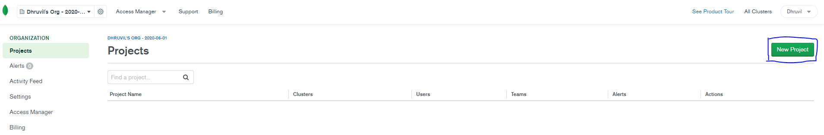

**Click the NEW PROJECT button.**

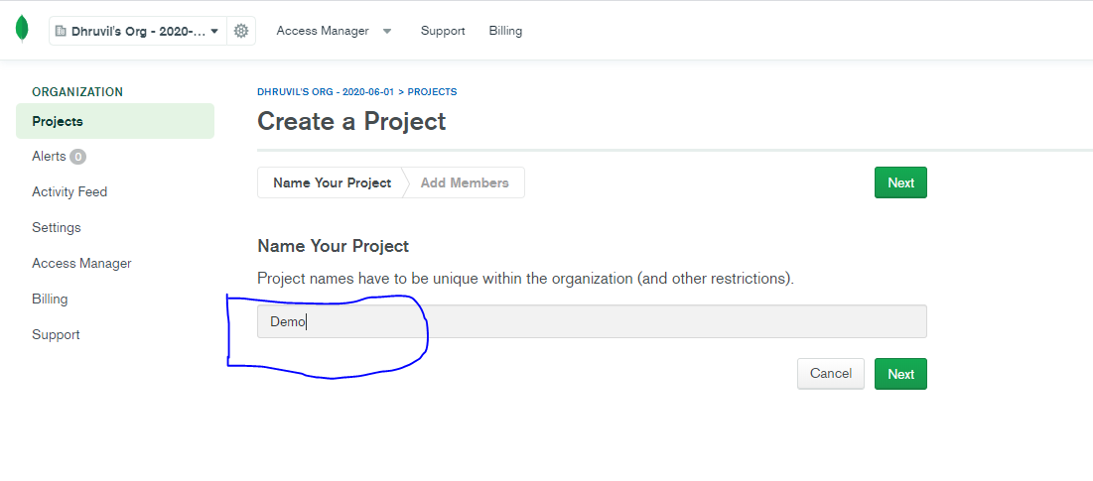

**Define your project name and click the next button.**

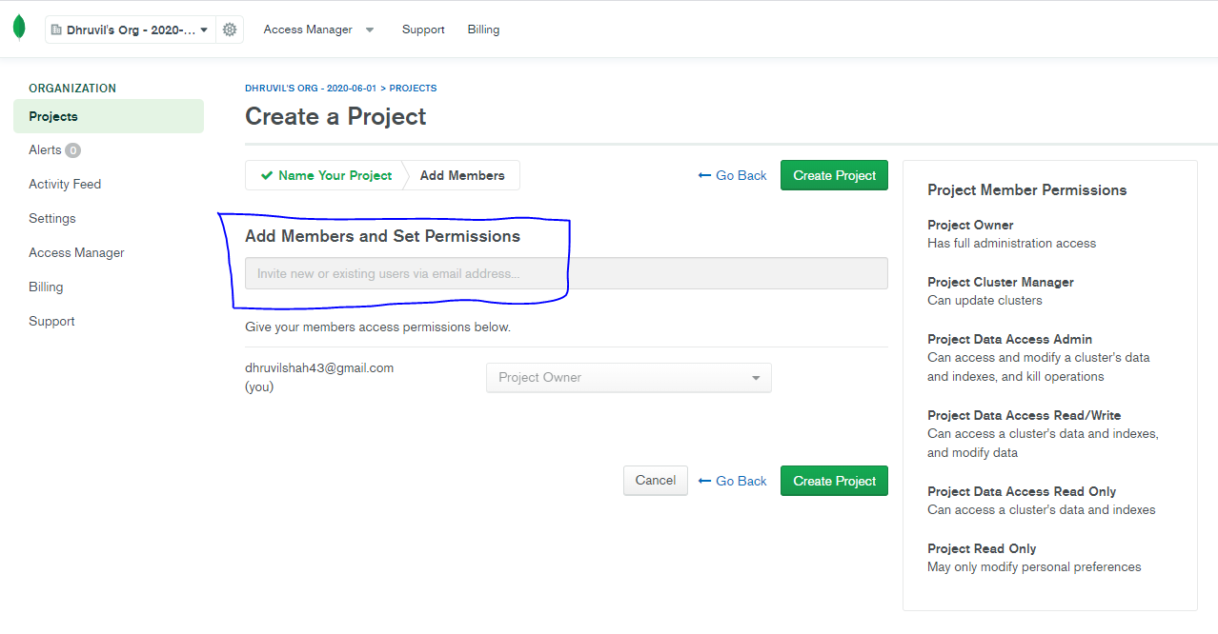

**(Optional)Also you can define add members and set permission then click create project button**

**Build Cluster:**

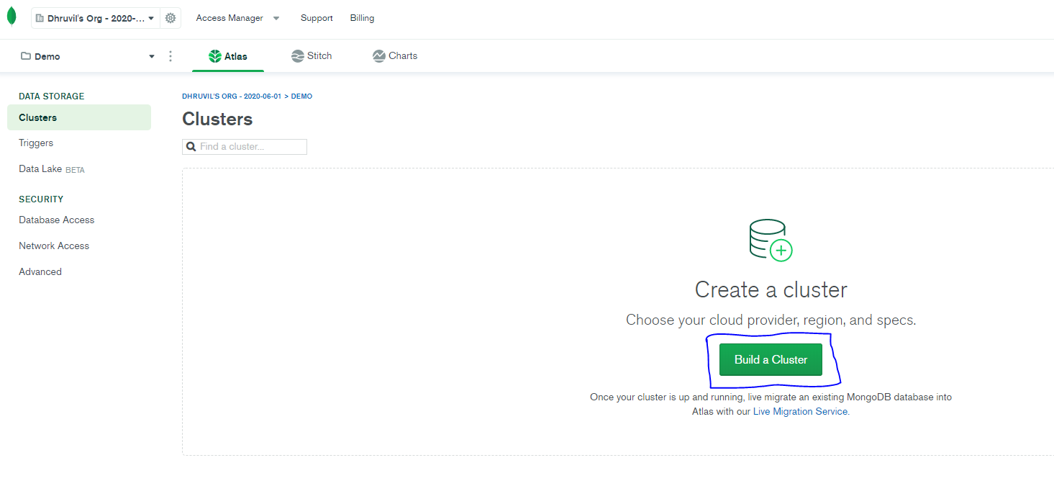

**Click on BUILD A CLUSTER button.**

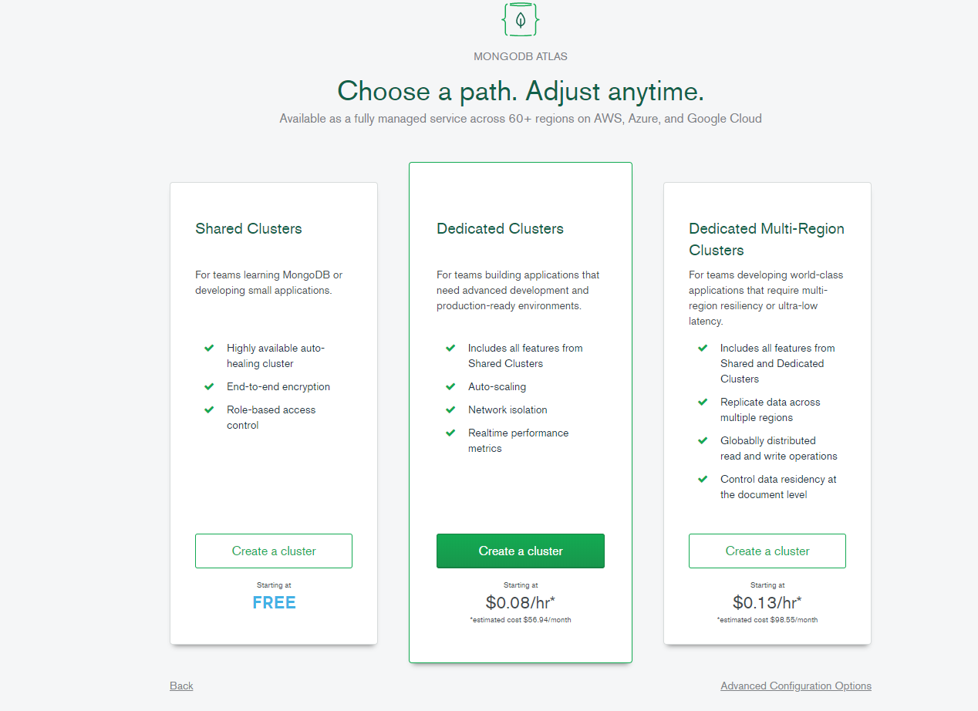

**Create a cluster your requirement. but I have to select FREE tire for practice.**

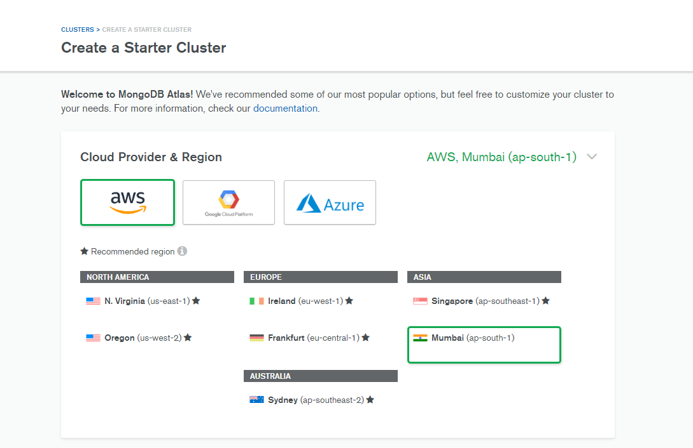

**Select the cloud provider and select the region.**

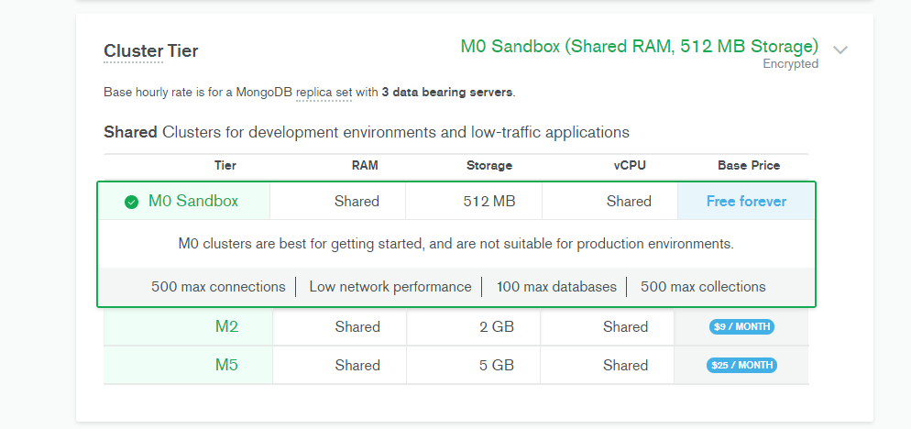

**Select the CLUSTER TIRE your requirement.(M0-M2-M5)**

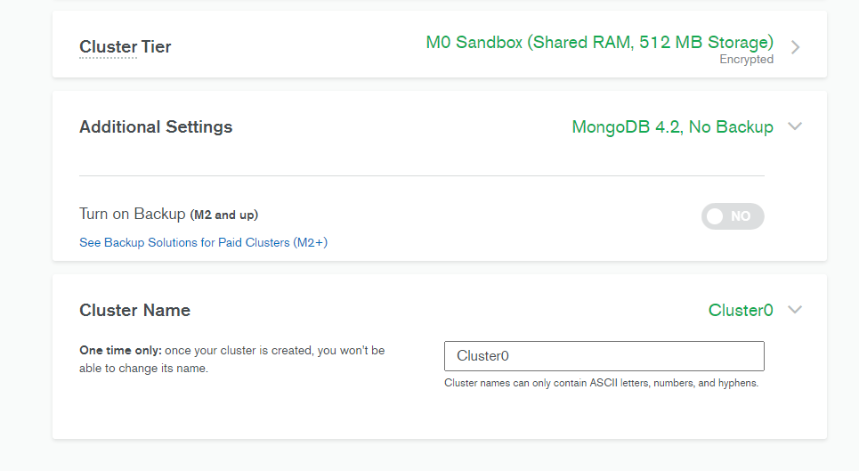

**Turn on Backup option and define the cluster name then press the button create cluster.**

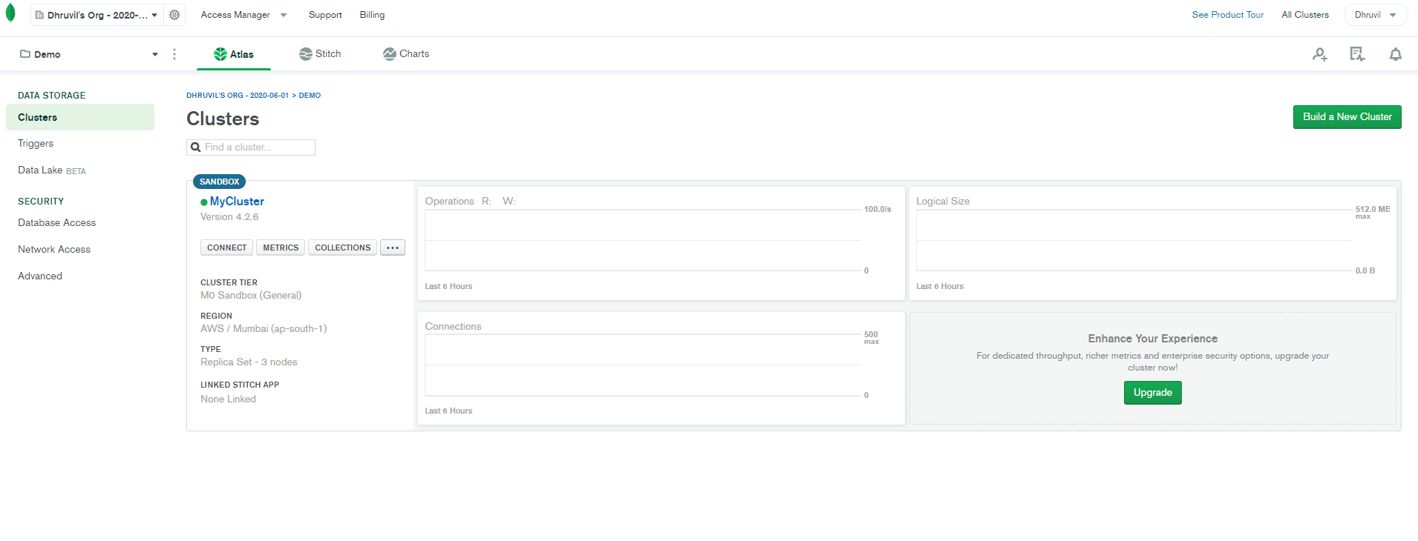

**Now Cluster is created.**

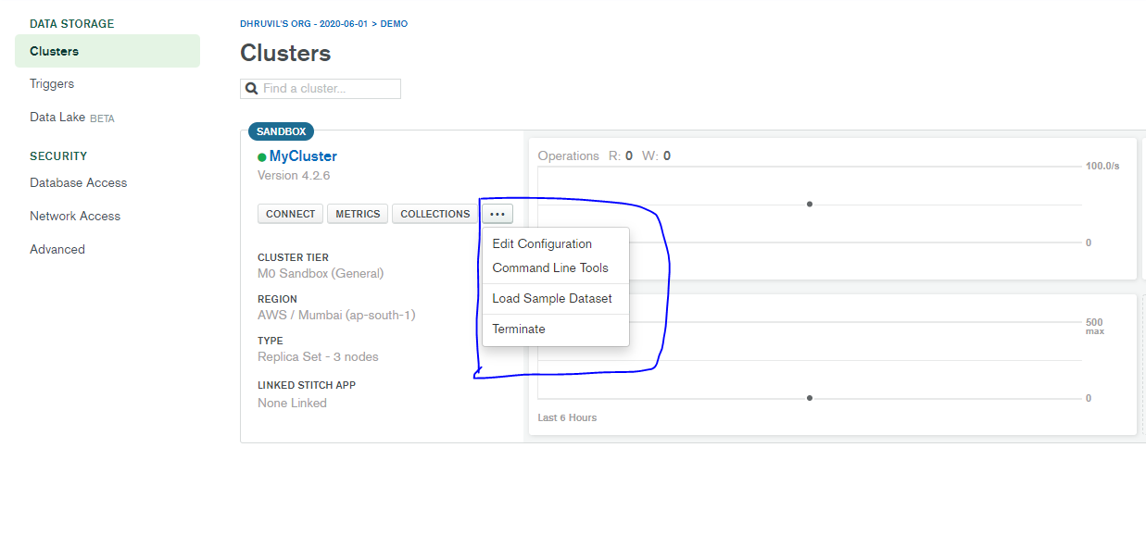

**You can edit the cluster and terminate also.**

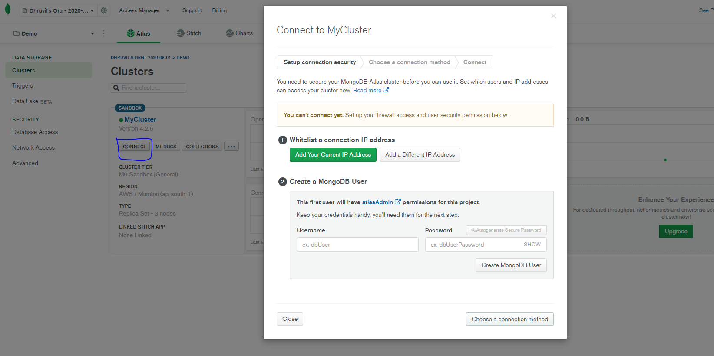

**Connect the cluster and you can create the MngoDB user.**

**And click on connection method button.**

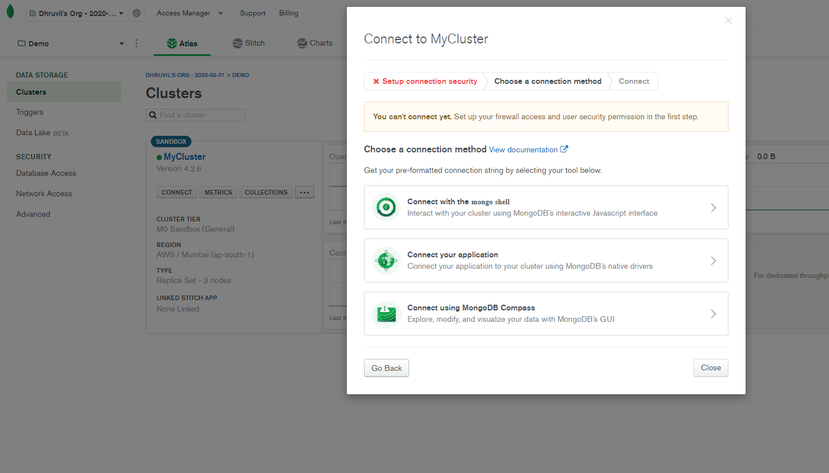

**You can select the different connection method and select the as par requirement.**

**Database Access:**

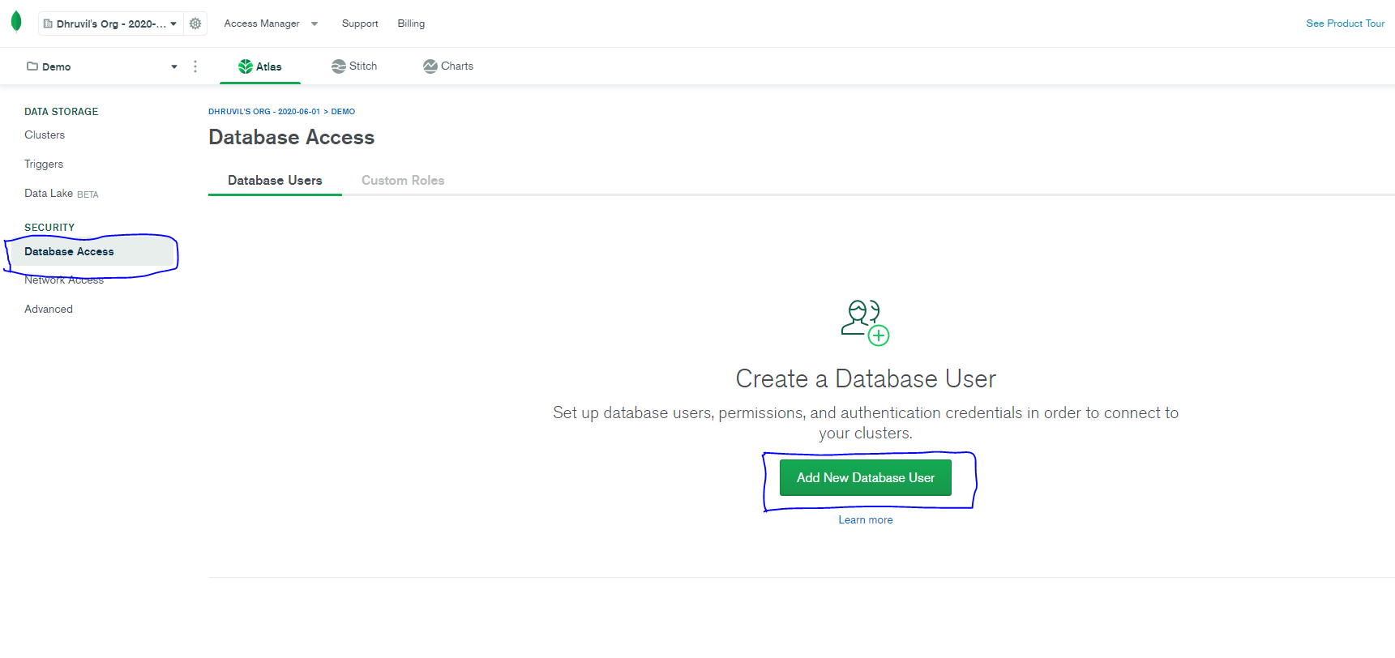

Select the right side DATABASE ACCESS. And create the Add New Database user.

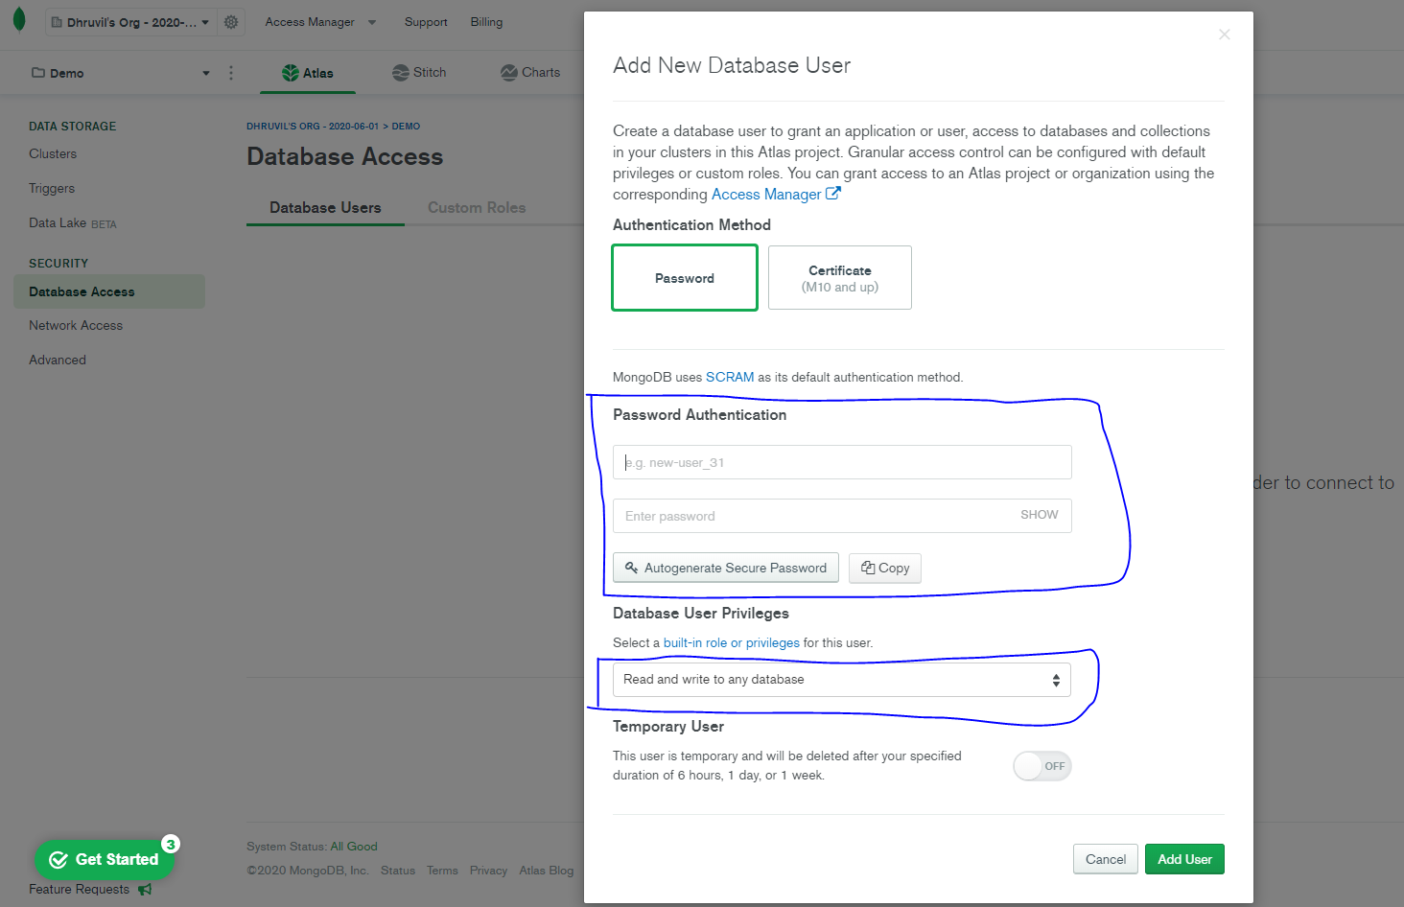

Define new user and password and select the database privileges. And click button of Add User.

**Network Access:**

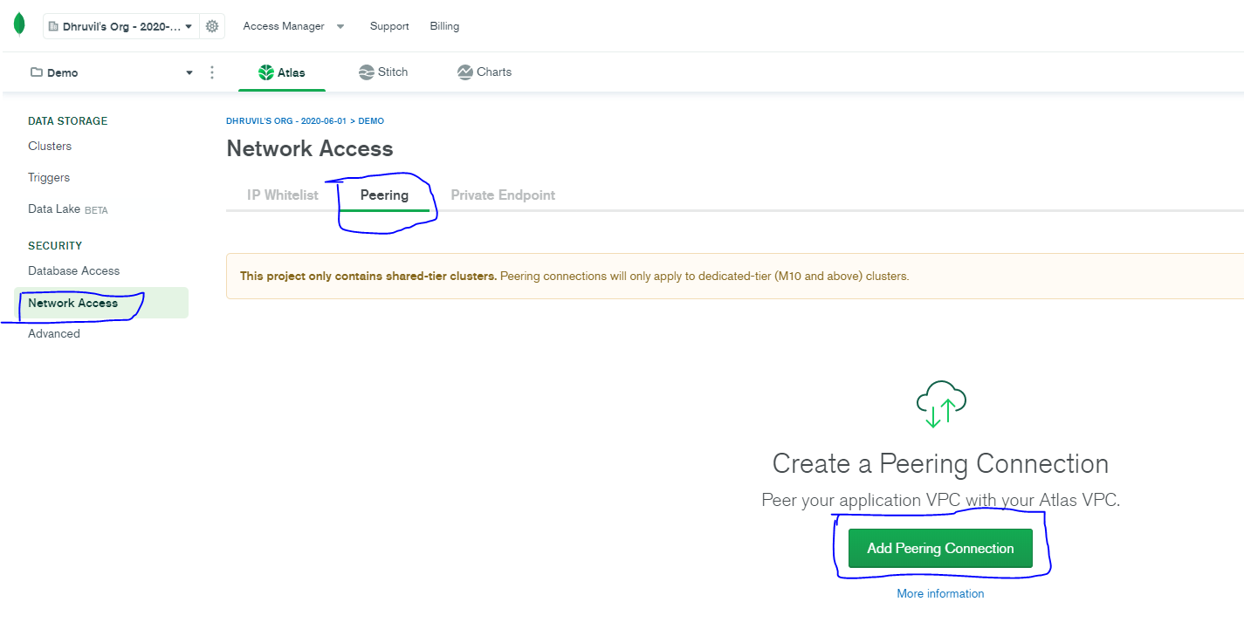

Select the left side NETWORK ACCESS and create the peering and click the ADD PERRING CONNECTION.

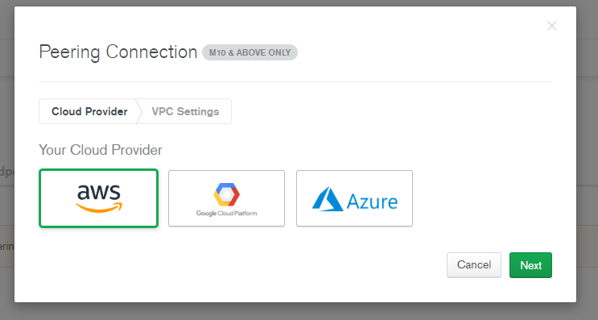

Select the Cloud Provider and click Next.

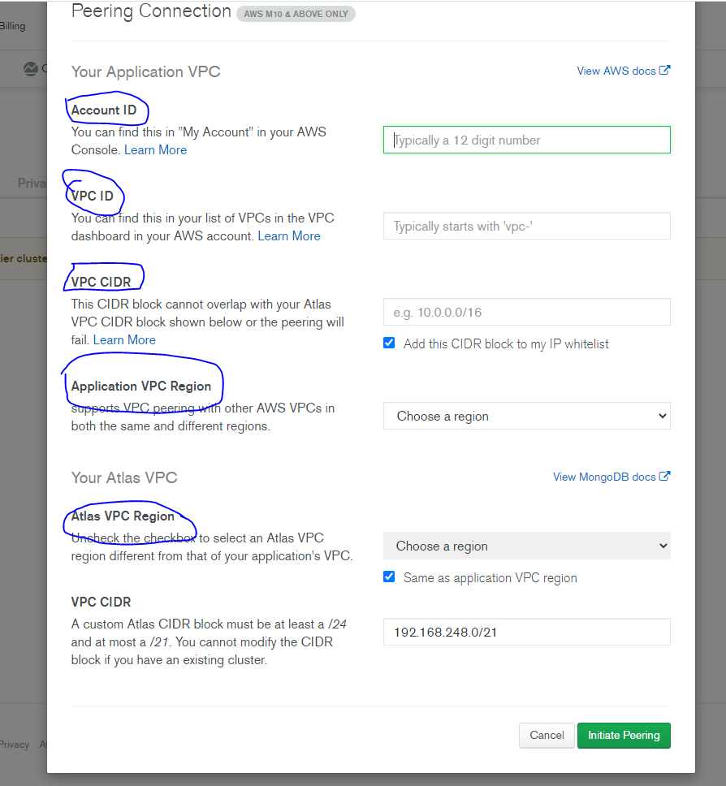

Enter the account id,VPC id,VPC CIDR,VPC region. and click the Intiate Peering.

* **Cluster Monitoring**:

